**Namibian Automatic WISN Loader (NAWL)**

**System Documentation**



P:\Logos\IH_LogoProffPrinting.tif

**Table of contents**

1. **Introduction**
2. **System requirement**
3. **Acknowledgements**
4. **Using NAWL**
   1. File structure
   2. Running the application
   3. Sorting the facilities
5. **Managing templates, All Service Statistics, All Regions**
   1. Managing Templates
   2. All Service Statistics
   3. All Regions
6. **Introduction**

The Workload Indicators of Staffing Need (WISN) software application is a tool for using a computer to record, analyze, and report data related to staffing requirements at health facilities. Learning to use this software is easy, but it assumes that you are familiar with the terms, concepts, and methodologies presented in the Workload Indicators of Stafﬁng Need (WISN) tool. Get more information in the user manual on the following WHO web site: <http://www.healthinternetwork.com/entity/hrh/resources/wisn_user_manual/en/index.html>.  Namibian Automatic WISN Loader (NAWL) is an external java application; build/developed to reduce the work of manually loading the facility data in WISN.

***(TECHNICAL)***

WISN files have a \*.wat extension and can be viewed in an xml format by renaming the file with a \*.xml extension. The NAWL uses this xml based template to load data in the template and save them as \*.wat per facility. NAWL uses three excel files which are ***all region.xls (containing all health facilities per region and district)***, ***OPD.xls (containing all service statistics per facility per cadre)*** and ***HR.xls (containing all current staffing per facility per cadre)*** as data containers which are then loaded in the templates to generate the WISN files (.wat). These \*.wat files generated by the NAWL can then be opened with the WISN software to run the reports that display the staffing needs.

1. **System requirements**

Please ensure that your computer meets or exceeds the following system requirements before installing the WISN application or the NAWL.

|  |  |
| --- | --- |
| Component | Specification |
| CPU | Intel Celeron 800 MHz (Intel Core 2 Duo 2 GHz recommended) |
| RAM | 256 MB (2 GB recommended) |
| Available disk space | 200 MB |
| Operating system | Windows 7, Windows Vista, or Windows XP |

1. **Acknowledgments**

IntraHealth Namibia expresses its gratitude to Nelson Claudiu Quimboca and the iHRIS team for the production of the NAWL application.

The iHRIS team includes Jason Ndemueda Ndemueda, Sam Boikie Naholo, Leena Ndapandula Shailemo, Rosaline Hendricks and all the MoHSS staff that indirectly contributed to the development and testing of this tool.

1. **NAWL installation**

The NAWL was developed using the Java Development Kit version 7 (JDK7) and the NetBeans IDE version 7.2. You first need to install the JDK7 then the NetBeans IDE.

1. **Using NAWL**
   1. **File structure**

NAWL requires several folders and files but here we will just be pointing out the most important ones that are required by the software. The templates and the excel files are explained in more details later in this document.

* Central: This folder contains all the \*.wat files for intermediate hospitals when they are generated by NAWL, the template file for intermediate hospitals, *central.wat* and *central.xml* is also read from here.
* Provincial: This folder contains all the \*.wat files for District hospitals generated
* With: This contains all \*.wat files for Health Centers generated
* Without: This contains all \*.wat files for Clinics generated

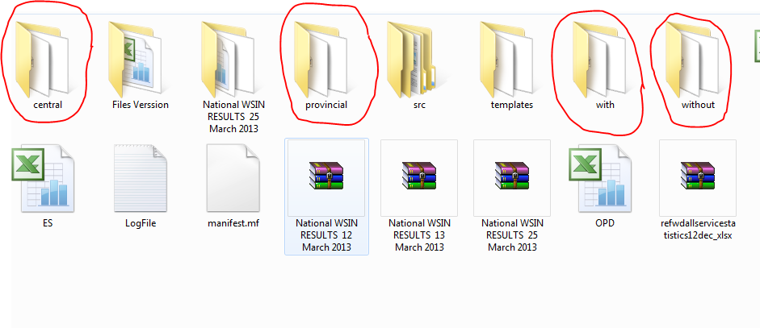

**Figure 1: NAWL folder structure**

***(Templates)***

The NAWL needs a template file per facility type. This template needs to contain all the activity standards, category allowances, individual allowances and the cadres per facility type. The NAWL will use this template as a baseline to create the \*.wat file per facility. The templates (central, provincial, with, without (.wat)) are respectively saved under abovementioned folders. An \*.xml file for each template is also created under each folder which enables the generation of the .wat files with service data and existing staffing inserted.

* 1. **Running the application**
     1. Running this application for the first time one has to navigate into the folder structure and just ensure that all the required files and folders as explained in section 4.1 are in place.

**When Templates (\*.wat) are modified**

When changes have been made to the templates, the new templates need to be moved to the respective folders and the old templates must be replaced. For example; if an activity is renamed for nurses in district hospitals, these changes have to be made in the central.wat template, and you replace the old template with the updated template in the central folder.

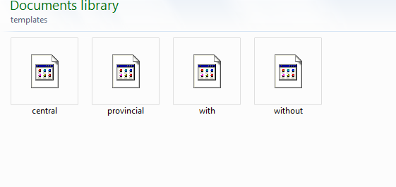

**Figure 2: The WISN facility templates**

**When excel files are modified**

In case of changes made to the excel file the ***content*** needs to be copied and used to replace the previous old ***content***. This excel files need to be saved in a *Microsoft Excel 97-2003 Worksheet (\*.xls)* format which allows the merging in xml. It’s very important that you do not just replace the files; otherwise the NAWL cannot read the files.

The columns in the ***All Service Statistic.xls*** file does not match the columns in the OPD. xls file; therefore the Facility\_type & Data\_Element columns in the ***All Service Statistic.xls*** needs to be deleted before copying the content to the ***OPD*** file. These columns are used for data quality checks and ensuring that all service statistics has been received for the facilities and is not used by the NAWL.

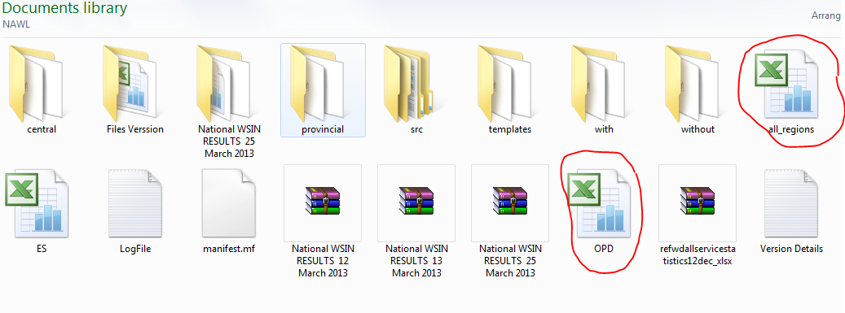

**Figure 3: The OPD and all\_Region excel files (*Microsoft Excel 97-2003 Worksheet (.xls))***

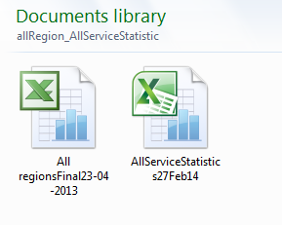

**Figure 4: Good practice to keep all the versions of the files you use as input with the files generated by the NAWL – helps with troubleshooting when the results of the WISN is being analyzed**

* 1. **Sorting the facilities**
     1. When the NAWL is done generation the WISN file for each of the facilities, one have to copy the \*.wat files from the default folder structure the into a folder structure that is easier for user to understand.

For example: files in the central folder into “Intermediate hospitals” folder, files in the provincial folder into into “District Hospitals”, etc. Also when you want to run summary reports, the WISN files for the facilities you want to compare has to be in the same folder so when you want to run a summary reports for all facilities within a region, all these WISN files have to be in the same folder. We used a specific naming convention that includes region and facility type to allow us to identify the type of facility by looking at the file name.

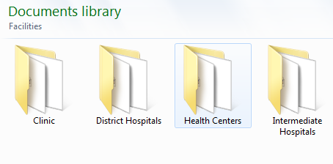

1. **Managing the input files** 
   1. **Managing Templates**

The templates need to be opened with WISN software for editing or modifying. This process need to be tracked to prevent using old templates which don’t have the latest activity standards. The name of the template should remain constant; the modified template should not be saved under a different name. We created a different folder for each time one of the activity standards changed to ensure the templates and the service statistics remain aligned.

* 1. **All Service Statistics**

This file contains all the service statistic data and it can be changed to any other excel format as long as the columns are maintained at all time to match the OPD file used by NAWL. The only exceptions are the facility type and data element columns that are being used for data quality checks only and deleted before the file is used by the NAWL.

* 1. **All Regions**

This file contains all region and facility by classification. The columns in this file matched the columns in the NAWL all regions file and needs to remain constant when changes made or new regions/facilities are added.

* 1. **HR Staffing**

This file contains current number of staff per cadre per facility.